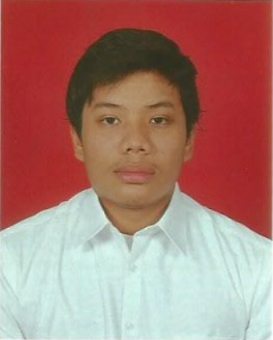

MUHAMMAD NUR HAZZIM BIN ABU HANIPAH

Contact Info
Address | :No.4, Jalan Kota Puteri 5/9A,  Kota Puteri Seksyen 5,  48100 Batu Arang,  Selangor Darul Ehsan.
Mobile No. | :012-9404084
Email | :hazzimabuhanipah@gmail.com

Personal Particulars
Age | :23
Date of Birth | :19/08/1994
Nationality | :Malaysia
Gender | :Male
Marital Status | :Single
IC No. | :940819-08-6157
Educational Background
Bachelor
Field of Study | : Bachelor Of Electrical Engineering With Honours
University | : Universiti Teknikal Malaysia Melaka (UTeM)
Graduation Date | : Ongoing
CGPA | : 2.78/4.00
Matriculation
School : Kolej Matrikulasi Perak (KMPk)
Finish Date : 29 April 2013
CGPA : 3.28/4.00

Sijil Pelajaran Malaysia (S.P.M)
School | : Sekolah Menengah Kebangsaan Puchong Utama (1)
Finish Date | : 31 December 2011
Gred | : 6A,3B
Experience History
1. PIZZA HUT AYER KEROH
Position Title | : Waiter
Position Level | : Fresh/Entry Level
Specialization | : Kitchen
Duration | : September 2015 - December 2015

WORK SCOPE
- Responsible in preparing and garnishing various kind of dishes offered in store.
- Loads and unloads materials and inventory while keeping products organized.

Top Skills
(Proficiency: Advanced - Highly experienced; Intermediate - Familiar with all the basic functionalities; Beginner - Just started using or learning the skill)
Skill | Month | Proficiency
MS Word, MS Excel | 12 | Intermediate
Dev C++, MinGW | 4 | Intermediate
MATLAB / Simulink  AutoCAD | 4  4 | Beginner  Intermediate
Domestic Wiring | 4 | Intermediate

Languages
(Proficiency: 0=Poor - 10=Excellent)
Language | Spoken | Written
Bahasa Malaysia | 10 | 10
English | 10 | 10

Additional Info
Career Objective
To gain as many knowledge and experience the industry had to offer

Strengths
- Able to handle basic tools and machinery as well as doing basic wiring
- Open to learn and accept new ideas, concept and knowledge when working in a team
- Able to communicate with people from tough backgrounds working in the field.
- Always keen to relate theoretical concept in class with hands on application in real life
- Always challenge self to work independently with minimum supervision.

Achievements
Year | Description
2017 | Made an Electrical Solar-Powered Trishaw for Third-Year Project

References
Dr. Maaspaliza bte Azri
Position : Academic Advisor
Company : Universiti Teknikal Malaysia Melaka
Email : maaspaliza@utem.edu.my

Dr. Mohd Luqman bin Mohd Jamil
Position : Deputy Dean
Company : Universiti Teknikal Malaysia Melaka
Email : luqman@utem.edu.my

